WHAT IS SAILABILITY?
RYA Sailability is a national charity that works closely with a variety of clubs, ensuring that people living with a long term health condition, a disability or are experiencing a level of vulnerability have the opportunity to learn to sail in safety. At Covenham they will be supported to experience the adventure and freedom that watersports provide, building up mobility, self-confidence, pride and improving their health and wellbeing through achievement. Sailing clubs throughout the country are encouraged to become affiliated to the National Group and provide training and sailing experiences to people in their own areas. Covenham has been affiliated to the RYA and federated to RYA Sailability since 1998

ABOUT COVENHAM…
Covenham Reservoir is a manmade reservoir with an area of 218 acres situated approximately mid way between Louth and Grimsby in East Lindsey District.

There have been water based activities at Covenham for over 40 years, but a state of the art watersports centre was completed in 2002 with all sections of the community being catered for. The building is on one level with wide doors allowing easy access for wheelchair users. The doors are not automatically opened. Parking has level access to the building with designated slots approx. 20 metres from the entrance for those with mobility issues. Changing rooms can accommodate wheelchairs and carers where required and we have a portable OXFORD hoist for indoors and a static hoist sits on a jetty to support our non-ambulant participants and their carers.

Covenham Sailability is run by a small, but dedicated team of volunteers who have over the years accumulated a wide range of equipment and experience to ensure that anyone who wants to try sailing can –irrespective of disability do so – in a safe and friendly atmosphere.

The sailing experience can range from a simple joy ride with little personal involvement to working towards RYA qualifications and independent
sailing to the level chosen by the individual. Everyone’s aspirations and needs are different, and all efforts are made to cater to all levels.

THE EQUIPMENT….

HANSA 303 dinghies of which we have 2 are a relatively new design and can accommodate up to two people. As a two-seater dinghy which are an excellent teaching platform especially for those with limited mobility. As a single seater they are ideal at allowing a disabled sailor to improve their skills and to be integrated into a group of able-bodied sailors on an equal footing.

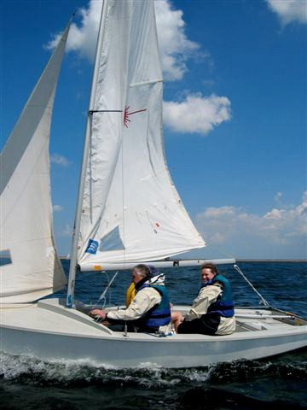
WAYFARER dinghies of which we have 2 allow people with some mobility to sail in relative comfort and space. These boats are very flexible and can cope with most reasonable conditions.
DRASCOMBE LUGGERS are a 20ft two-masted keel-boat, very roomy and stable. Suitable for taking groups of up to six adults and children who can support themselves. They can be sailed with various sail combinations to suit the prevailing conditions. Can also be rowed or motored if there is no wind.
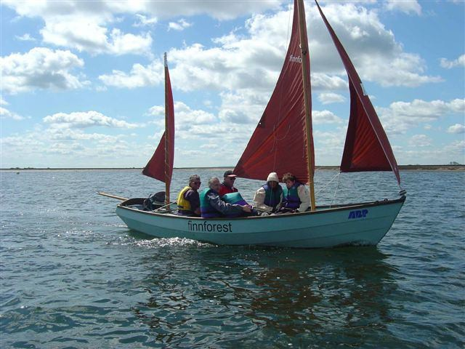

HANSA LIBERTY This is a single handed dinghy which can be sailed either manually or using automated systems controlled by a joystick for those with dexterity or strength issues with their hands.

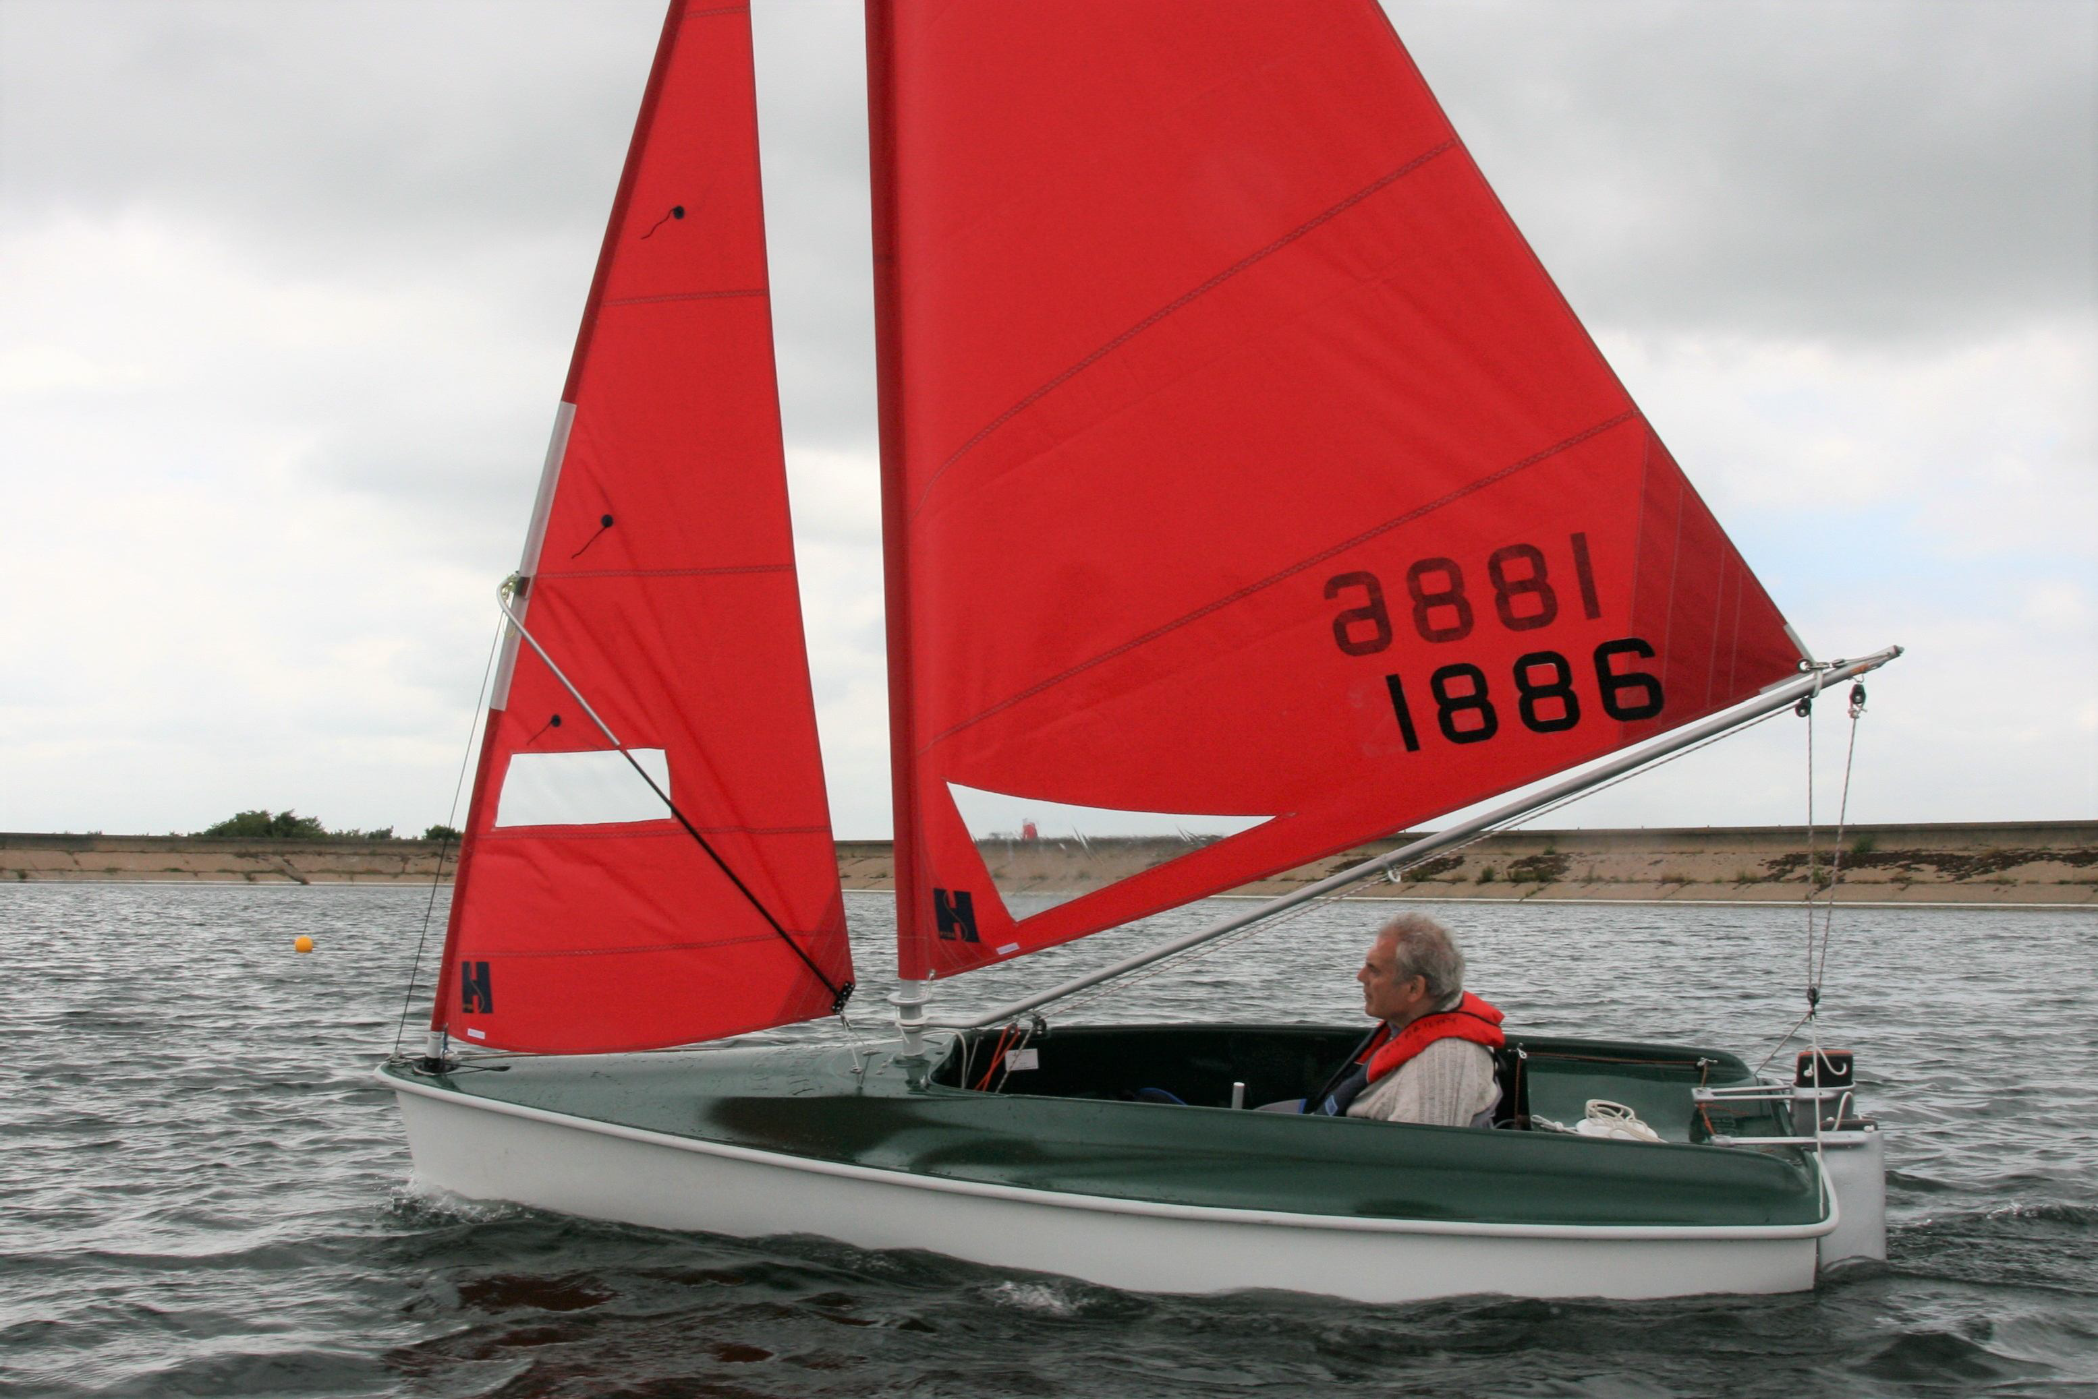

TOPPER SPORT 14 dinghy is a very stable and roomy boat which is adaptable to suit most reasonable conditions for those with full mobility.

CHALLENGER TRIMARAN is a very stable three hulled boat designed for those with very little or no mobility. It is sailed with the support of an instructor riding on a platform between the hulls.

4.7m RIB with 40hp engine is used as our dedicated safety boat. Always manned by a competent trained crew of at least two people.

A range of protective CLOTHING in a variety of sizes, designed to keep the sailor warm and dry is available for use. Buoyancy aids and self-inflating lifejackets are available as required by our participants needs. We recommend all participants bring additional warm casual clothes and soft soled footwear, and a change of clothes incase they get wet and cold.

When Does it happen?
Fortnightly on Saturdays after Easter until the end of October from 09.30 to 16.00, dates for the current year are available on request our club website and facebook page or on request.

We are very aware that our participants are particularly vulnerable and every effort will be made to identify how we best support them. We like to discuss each individuals needs to give us the best chance of meeting them. A detailed health form helps us understand some of these needs. We ask that all participants provide full details of medical conditions and medication being taken. If necessary, this will be taken on the water with the individual.

How to contact us…

If you would like more information on Sailability at Covenham please contact:

Robert Caudwell. (Chairman):
Tel: 01754820286
Email: gh_caudwell@btconnect.com

Email: covenhamsailability.secretary@outlook.com

Judith Templeman -Senior instructor Sailability
07733510460 templemanjudy@hotmail.com

Website: https://www.covenhamsc.co.uk/sailability

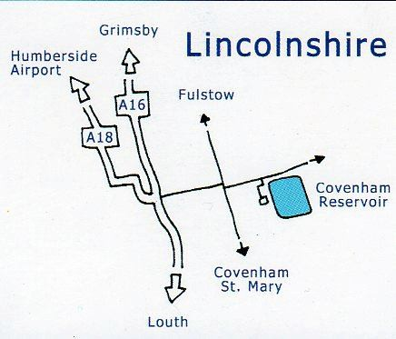
Covenham
Sailability

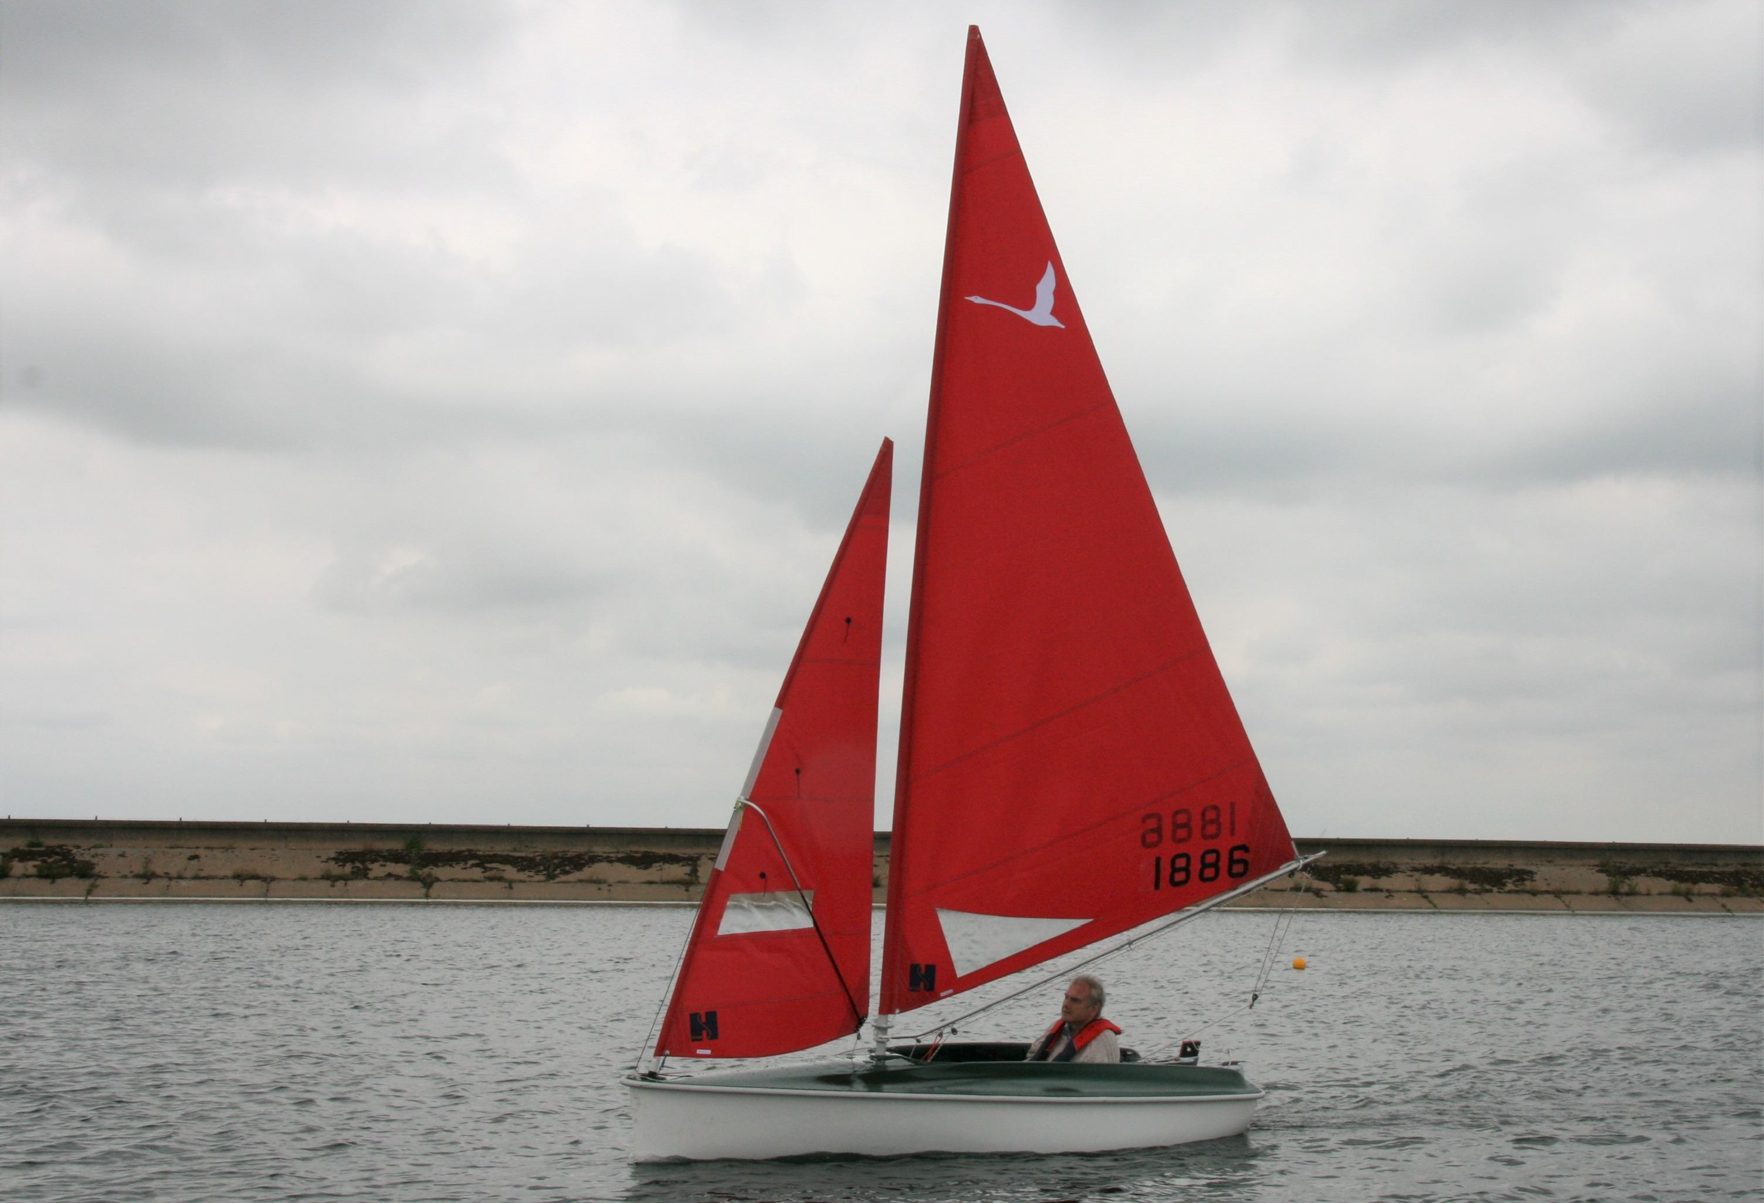
Part of
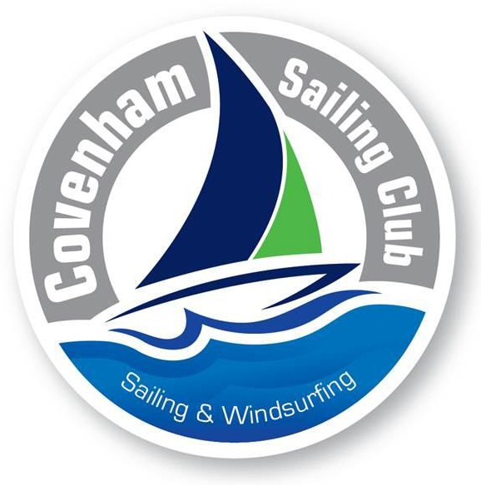
And federated to
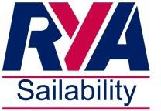
RYA Sailability

