3
Contacts are
Commodore Phil Nickells 07713068398
Vice commodore Sam Hammond
Secretary Greg Baldock 07546225906
Treasurer /membership Judith Templeman 07733510460
Principal of training Simon Thompson 07392009319
Bosun Dave Burrell
Paddleboard rep Ben Burley
Malcolm Willison
Richard Butler

Web Site https://www.covenhamsc.co.uk/
Face Book https://www.facebook.com/groups/covenhamsc

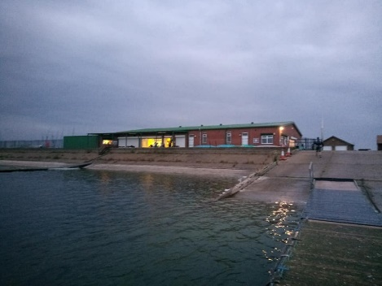

Gate Keys
Keys can be provided on payment t of a refundable deposit on the return of said key of £25.00
Security codes will then be provided

WELCOME TO COVENHAM SAILING CLUB

You have made the decision to join Covenham Sailing club and we are delighted to welcome you to our club. Our club needs active members so we look forward to seeing you at the club.
Background 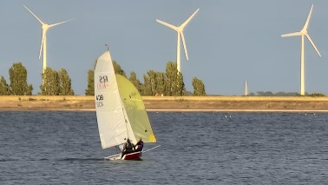
The club house is secured on a site leased from Anglian Water, and is run by the Covenham Watersports Association, who maintain it using a contribution from each of its member clubs:
- Covenham Sailing club
- Covenham Water ski club
- Grimsby & Cleethorpes sub aqua club
- Covenham Sailing club & Covenham Water ski club share access to the water.
The club is located in East Lindsey District of Lincolnshire, where there are few sporting venues.
Nearby urban communities have large numbers of unemployed, wages can be lower than the national average. We rely hugely on voluntary help by our members which in itself can demonstrate a value.
All of these factors help us successfully apply for funding as well as support from our National Governing body and Sport England Lottery funding.
Currently volunteers form the committee, deliver training, share safety cover for club sessions, carry out repairs on training equipment and the site. Across the membership the club draws on the skills available, and the willingness to share those skills for the benefit of all. Without that contribution from our members both financial and their time we would have to pay for jobs to be done, which might increase our costs and so our membership fees
These volunteers give their time freely and we , as a club, recognise their contribution by supporting them with training to develop their skills further and endeavouring to provide a calendar of activities to suit all ages and abilities.
Entry is via gates which are locked to protect boats and equipment for which a key can be provided on payment of a refundable deposit of £25.00 on its return.
Membership
The club supports its members by offering membership fees that reflect the different needs of various users. We recognise that financial pressures on us all have increased so if you need to discuss a plan that works for you – just give the membership secretary a call- in strictest confidence.
- Family
- Single
- 18-25 years
- Under 18 years
- Group (up to 10 persons)
- Volunteer ( non-water users)
- Sailability (for people who live with any of the protected characteristics)
Membership fees and income from training make up the income which enables the club to operate. This income is supplemented by grants to support activities.
For your membership fee the club provides
- a state-of-the-art club house,
- social room,
- access to refreshments,
- Changing rooms with showers
- Comprehensive training programme
- Access to training equipment (clothing and boats)
- Age-appropriate activities
- Access to the water-based activities is provided on a shared basis between the clubs belonging to Covenham Watersports association.
- Disabled facilities including parking spaces near to the club entrance, single level access and fully equipped changing rooms including an electric hoist
- Training courses across dinghy sailing, windsurfing, and powerboat and access to paddleboard sessions- all delivered by volunteers within the club
The sailing club has access to the water: -
Monday – Friday Dawn to 16.00
Wednesday 18.00-Dusk
Thursday 18.00-Dusk
Saturday Dawn till Dusk
Sunday (summer) 13.00-18.00
Sunday Winter 11.00-13.00
Non-Members
Non-members are welcome to participate on payment of a day fee

Training
Training courses are made available subject to the availability of the volunteers within the club
Club members are encouraged and supported to up-skill and even consider instruction qualifications.

What do you give the club?

- Payment of membership by April 1st each year
- Payment of berth fee by April 1st each year
- Completion of membership form by April 1st each year
- Displaying the boat sticker that demonstrates you have paid your berth fee on the transom of your boat.
- Making sure you are aware of the water safety policy and adhering to it
- Carrying out safety cover and race officer duties as requested – with training & support if required
- Joining in club clear up days – where possible
- Mopping up any water in changing room after use and leaving areas used tidy.
- Placing rubbish in the bins provided and if you see they are full- empty them in the skip outside
- Ensuring your boat, if you have one on the dinghy park is tied down safely, insured appropriately and the ground around your boat is cleared of weeks and plant growth.
- Ensuring the building and gate are secured if you are last to leave the site
- Returning the keys to their location in the entrance foyer, when they have been used.
- Complete club surveys and questionnaires if requested, to help us shape the club.
- Participate in social activities and fund raising activities – if available.
- Support your family member in the pursuit of their sport by helping us provide you with facilities to help you enjoy the site too- if not a water sport participant

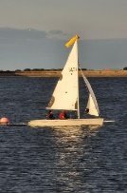
Equipment Hire
Training boats and protective clothing is available for use, for a small donation to support on-going replacement and maintenance, when it’s not needed for training purposes

